1. ALLOW USER TO INSERT PINCODE IN A FORM . PRINT ALL AREAS OF THAT PIN CODE. **( DIFFICULTY LEVEL HIGH )**

API LINK : [https://api.postalpincode.in/pincode/{pincode](https://api.postalpincode.in/pincode/%7Bpincode)}

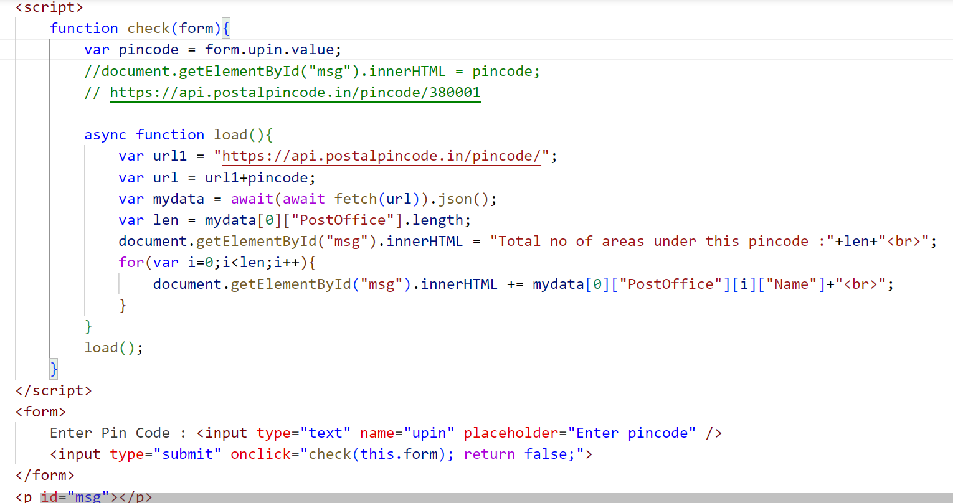

OUTPUT SS :

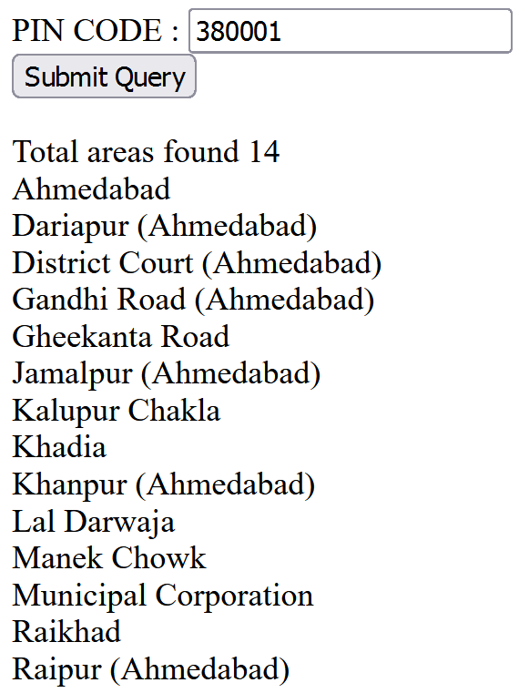

1. ALLOW USER TO INSERT CATEGORY IN A FORM . PRINT ALL NEWS OF THAT CATEGORY.

API : [https://inshortsapi.vercel.app/news?category=](https://inshortsapi.vercel.app/news?category=sports){category}

User Input :

sports

business

entertainment

politics

startup

national

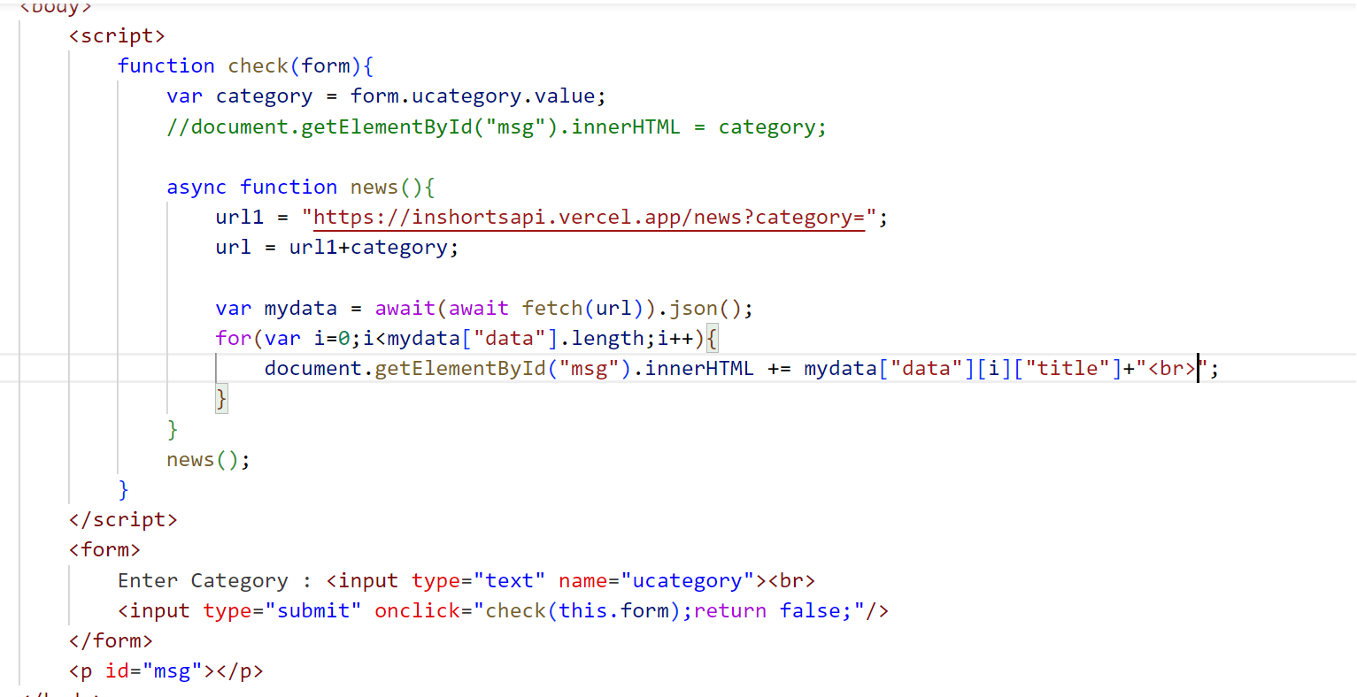

1. PROGRAM 1 : If user enters wrong category output should be

Invalid category / No data found

1. PROGRAM 2 : Create a dropdown of all categories and provide a submit button.

3) [IMPORTANT : VERY POPULAR API - TAKEN FROM INTERVIEWS ] Allow user to insert word. Print meaning of that word.

API : [https://api.dictionaryapi.dev/api/v2/entries/en/{Word](https://api.dictionaryapi.dev/api/v2/entries/en/%7BWord)}

Sample : <https://api.dictionaryapi.dev/api/v2/entries/en/hello>